**Practical 02**

**Working with Object Oriented C# and ASP .NET .**

1. **Create simple application to perform following operations**
2. **Finding factorial Value :**

**Code :**

using System;

using System.Collections.Generic;

using System.Linq;

using System.Text;

using System.Threading.Tasks;

namespace ConsoleApp1

{

class Program

{

static void fact()

{

Console.Write("Enter a number to find factorial: ");

int n = Convert.ToInt32(Console.ReadLine());

if (n == 0 || n == 1)

n = 1;

long fact = 1;

for (int i = 2; i <= n; i++)

{

fact *= i;

}

Console.WriteLine($"Factorial of {n} is: {fact}");

Console.ReadLine();

}

static void Main(string[] args)

{

fact();

}

}

}

**Output :**

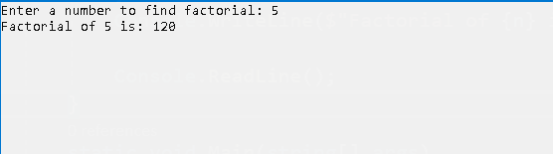

**ii. Money Conversion :**

**Code :**

using System;

using System.Collections.Generic;

using System.Linq;

using System.Text;

using System.Threading.Tasks;

namespace ConsoleApp1

{

class Program

{

static void mconvert()

{

Console.Write("Enter amount in USD: ");

decimal usd = Convert.ToDecimal(Console.ReadLine());

decimal convertedAmount = ConvertToINR(usd);

Console.WriteLine($"Amount in INR: {convertedAmount}");

Console.ReadLine();

}

static decimal ConvertToINR(decimal usd)

{

decimal conversionRate = 79;

return usd * conversionRate;

}

static void Main(string[] args)

{

mconvert();

}

}

}

**Output :**

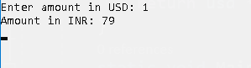

**iii. Quadratic Equation :**

**Code :**

using System;

using System.Collections.Generic;

using System.Linq;

using System.Text;

using System.Threading.Tasks;

namespace ConsoleApp1

{

class Program

{

static void qequation()

{

Console.WriteLine("Enter coefficients (a, b, c) of the quadratic equation ax^2 + bx + c = 0:");

Console.Write("Enter a: ");

double a = Convert.ToDouble(Console.ReadLine());

Console.Write("Enter b: ");

double b = Convert.ToDouble(Console.ReadLine());

Console.Write("Enter c: ");

double c = Convert.ToDouble(Console.ReadLine());

double discriminant = b * b - 4 * a * c;

if (discriminant > 0)

{

double root1 = (-b + Math.Sqrt(discriminant)) / (2 * a);

double root2 = (-b - Math.Sqrt(discriminant)) / (2 * a);

Console.WriteLine($"Roots are real and different.\nRoot1 = {root1},Root2 = { root2} ");

}

else if (discriminant == 0)

{

double root = -b / (2 * a);

Console.WriteLine($"Roots are real and same.\nRoot = {root}");

}

else

{

double realPart = -b / (2 * a);

double imaginaryPart = Math.Sqrt(-discriminant) / (2 * a);

Console.WriteLine($"Roots are complex.\nRoot1 = {realPart} + {imaginaryPart}i, Root2 = {realPart} - {imaginaryPart}i");

}

Console.ReadLine();

}

static void Main(string[] args)

{

qequation();

}

}

}

**Output :**

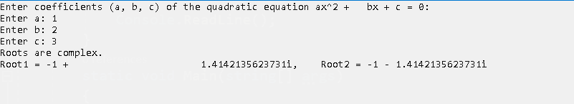

**iv. Temperature Conversion :**

**Code :**

using System;

using System.Collections.Generic;

using System.Linq;

using System.Text;

using System.Threading.Tasks;

namespace ConsoleApp1

{

class Program

{

static void temp()

{

Console.Write("Enter temperature in Celsius: ");

double celsius = Convert.ToDouble(Console.ReadLine());

double fahrenheit = celsius * 9 / 5 + 32;

double kelvin = celsius + 273.15;

Console.WriteLine($"Temperature in Fahrenheit: {fahrenheit}");

Console.WriteLine($"Temperature in Kelvin: {kelvin}");

Console.ReadLine();

}

static void Main(string[] args)

{

temp();

}

}

}

**Output :**

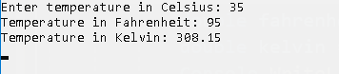

1. **Create simple application to demonstrate use of following concepts .**
2. **Function Overloading :**

**Code :**

using System;

namespace ConceptsDemo

{

// Base class for inheritance demonstration

public class Animal

{

public string Name;

// Constructor overloading

public Animal()

{

Console.WriteLine("Animal created.");

}

public Animal(string name)

{

Name = name;

Console.WriteLine($"Animal created with name: {name}");

}

public void Speak()

{

Console.WriteLine("Animal speaks.");

}

}

// Single Inheritance: Dog class inherits from Animal class

public class Dog : Animal

{

public Dog() : base()

{

Console.WriteLine("Dog created.");

}

public Dog(string name) : base(name)

{

Console.WriteLine($"Dog created with name: {name}");

}

public void Bark()

{

Console.WriteLine("Dog barks.");

}

}

// Multilevel Inheritance: Puppy class inherits from Dog class

public class Puppy : Dog

{

public Puppy() : base()

{

Console.WriteLine("Puppy created.");

}

public Puppy(string name) : base(name)

{

Console.WriteLine($"Puppy created with name: {name}");

}

public void Play()

{

Console.WriteLine("Puppy plays.");

}

}

// Hierarchical Inheritance: Cat class also inherits from Animal class

public class Cat : Animal

{

public Cat() : base()

{

Console.WriteLine("Cat created.");

}

public Cat(string name) : base(name)

{

Console.WriteLine($"Cat created with name: {name}");

}

public void Meow()

{

Console.WriteLine("Cat meows.");

}

}

// Class demonstrating function overloading

public class Calculator

{

// Function overloading with different parameter counts

public int Add(int a, int b)

{

return a + b;

}

public int Add(int a, int b, int c)

{

return a + b + c;

}

// Function overloading with different parameter types

public double Add(double a, double b)

{

return a + b;

}

}

class Program

{

static void Main(string[] args)

{

Console.WriteLine("Function Overloading Demo:");

Calculator calc = new Calculator();

Console.WriteLine($"Add(2, 3): {calc.Add(2, 3)}");

Console.WriteLine($"Add(2, 3, 4): {calc.Add(2, 3, 4)}");

Console.WriteLine($"Add(2.5, 3.5): {calc.Add(2.5, 3.5)}");

Console.WriteLine("\nSingle Inheritance and Constructor Overloading Demo:");

Dog dog = new Dog("Buddy");

dog.Speak();

dog.Bark();

Console.WriteLine("\nMultilevel Inheritance Demo:");

Puppy puppy = new Puppy("Charlie");

puppy.Speak();

puppy.Bark();

puppy.Play();

Console.WriteLine("\nHierarchical Inheritance Demo:");

Cat cat = new Cat("Bittu");

cat.Speak();

cat.Meow();

Console.WriteLine("\nConstructor Overloading Demo:");

Animal animal1 = new Animal();

Animal animal2 = new Animal("Monkey");

Console.ReadLine();

}

}

}

**Output :**

